OUTLINE
- Introduction
- Data Description
- Data Organization
- Dashboard details
- Advanced Analysis

1. Introduction
General overview and Tool Used ( em recommend Tableau - nếu nó lạ với mấy anh chị em có thể giúp để mình học nhiều cái mới hơn ha mn)

2. Data Description:
Describe the information of data ( Order-Column-Value-Description detail)

3. Data Organization (Chi)
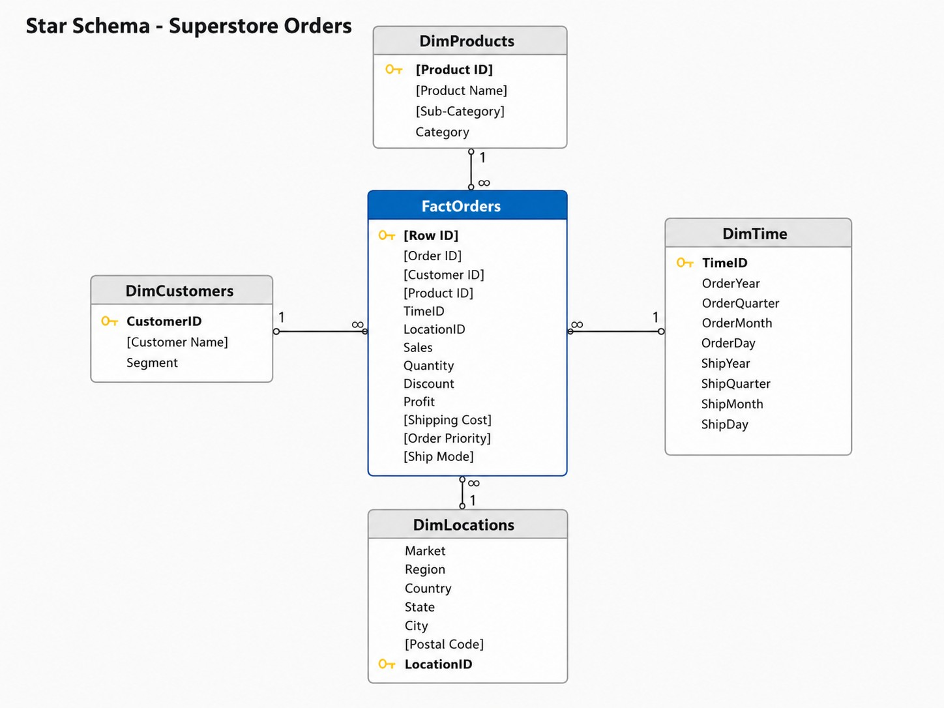
Chúng ta có thể nâng cấp lên bằng cách load cấu trúc trên vào database và sau đó connect database này vào tableau hoặc python để phân tích

4. Dashboard details
- Overview (Hung)
- 5 KPI cards: Sales, Profit , Margin 12.5%, Orders 5,009, Customers 793.
- Line chart of Sales & Profit by month (2014–2017) → captures seasonality and YoY growth momentum.
- Mini-breakdown of revenue across the 3 pillars: Region · Category · Segment (small donut or bar) to lead into the later parts.
- Global filters (apply across all 3 parts): Year, Region, Segment, Category.
Hưng does it:
The overall KPI cards:
The overall KPI cards show that Superstore generated approximately $2.30M in sales and $286.4K in profit, with an overall profit margin of around 12.5%. Although the company has a large customer base and more than 5,000 orders, the margin indicates that profitability still needs to be monitored carefully. Therefore, management should not focus only on revenue growth, but also on profit quality.
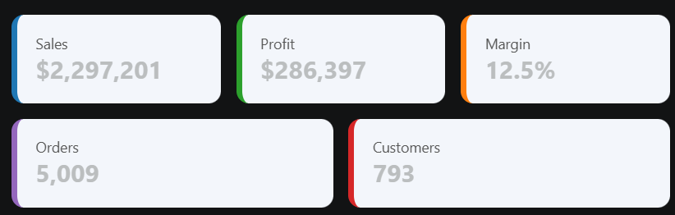
Sales and Profit by Month:
While long-term revenue shows strong upward momentum (peaking in 2017 at $733.2K), profit growth is beginning to lag behind sales growth. In 2016, profit growth outpaced sales (32.7% vs. 29.5%), but in 2017, a 20.4% jump in sales yielded only a 14.2% increase in profit. This disconnect is most visible at the monthly level: the highest-grossing month on record (November 2017 at $118.4K) failed to generate the highest return, which instead occurred a year earlier (December 2016 at $17.9K).
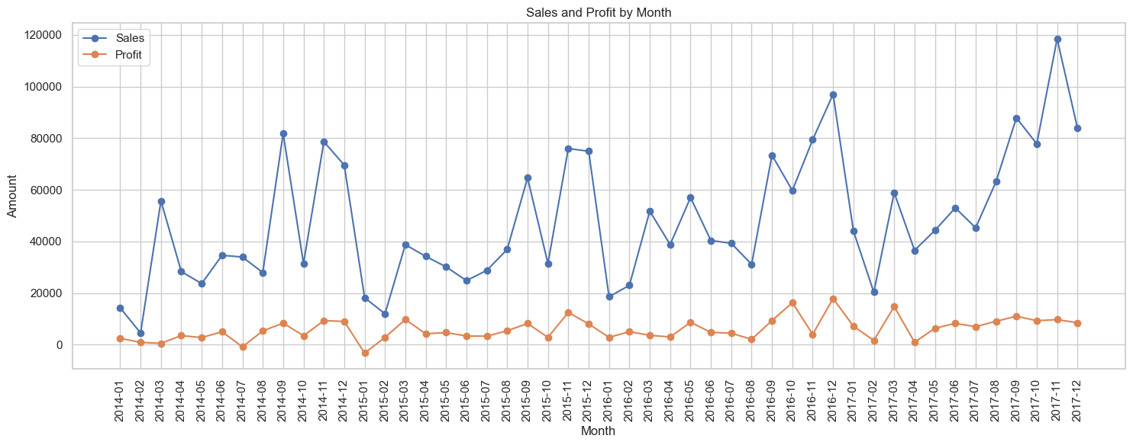
Year-over-Year Growth: Sales vs Profit
Year-over-year data reveals a concerning shift in the company's growth dynamics. From 2014 to 2016, the business demonstrated excellent efficiency—particularly in 2015, where a slight dip in sales still yielded higher profits, followed by strong, balanced growth in 2016. However, 2017 exposes a breakdown in this efficiency: while top-line sales continued to expand significantly to $733.2K, the overall profit margin contracted from 13.4% down to 12.7%.
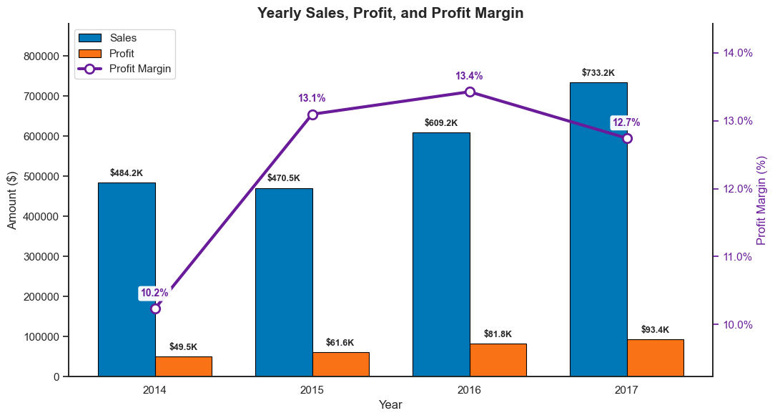
Revenue Breakdown by Region:
West is the strongest region, contributing 31.6% of total sales and 37.9% of total profit. East also performs well, with 29.5% of sales and 32.0% of profit. In contrast, Central contributes 21.8% of sales but only 13.9% of profit, showing weak profit conversion. South has the smallest sales share at 17.1%, but its profit share is slightly better at 16.3%. Overall, Central should be reviewed for possible issues in pricing, discounting, product mix, or cost structure.
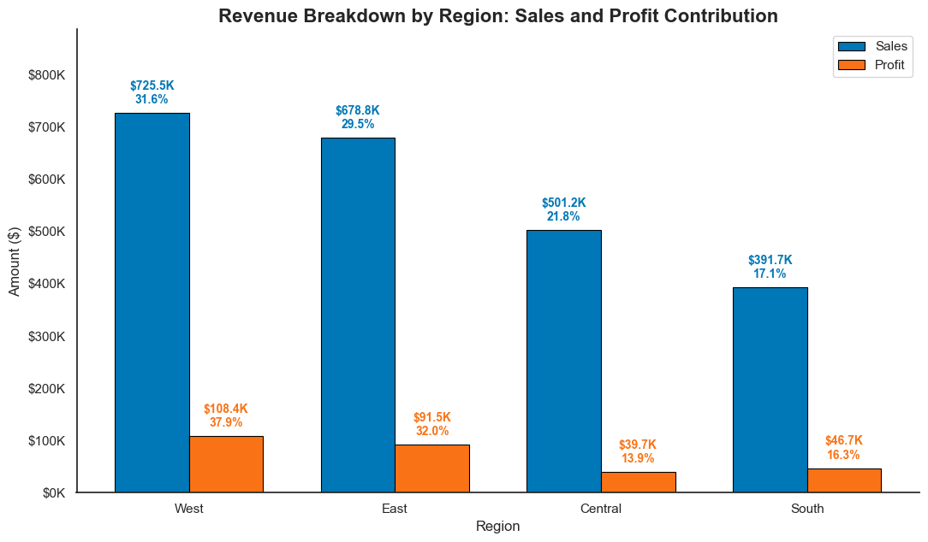
Top 10 States by Sales with Profit:
The Top 10 States by Sales with Profit chart shows that California and New York are the strongest markets in terms of both revenue and profitability. California contributes the largest share of total sales at $457.7K, representing 19.9% of total sales, and generates $76.4K in profit. New York also performs strongly, contributing $310.9K in sales and $74.0K in profit.
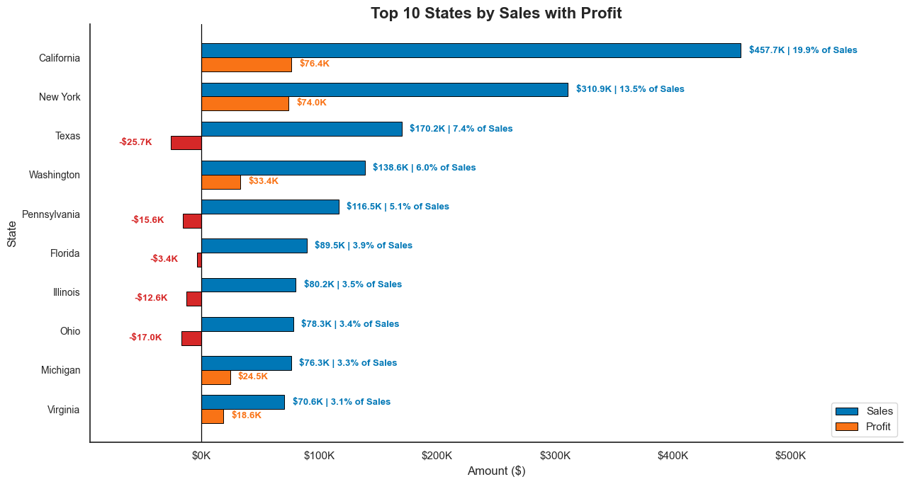
Bottom 10 States by Profit with Sales:
However, The Bottom 10 States by Profit with Sales chart also reveals that high sales do not always lead to positive profit. Texas is the most critical example: although it ranks third in sales with $170.2K, accounting for 7.4% of total sales, it generates a loss of $25.7K. Pennsylvania, Illinois, Ohio, and Florida also appear among the top sales states but produce negative profit. This indicates that these states have strong revenue volume but poor profit conversion.

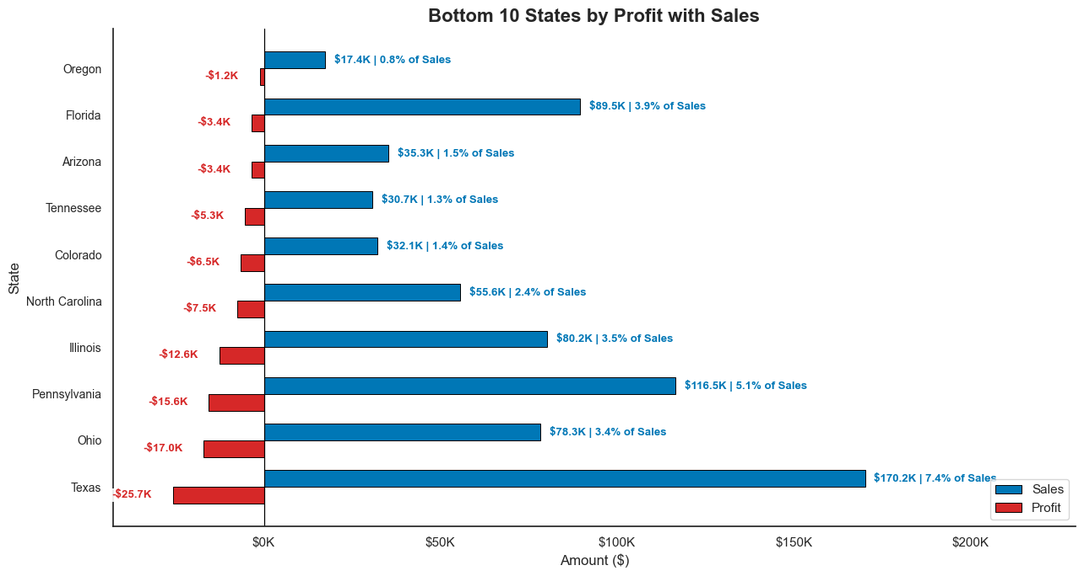
Revenue Breakdown by Category:
Technology is the best-performing category, contributing 36.4% of total sales but 50.8% of total profit. Office Supplies also shows strong profitability, with 31.3% of sales and 42.8% of profit. In contrast, Furniture contributes 32.3% of sales but only 6.4% of profit, indicating weak profit conversion.
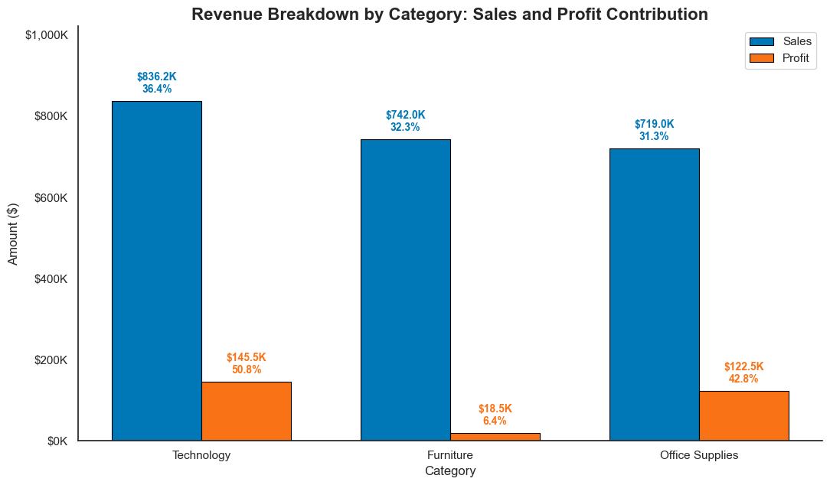
Profit by Sub-Category:
Sub-category analysis reveals a stark contrast in profit generation. Technology and Office Supplies drive the bottom line—led by Copiers ($55.6K), Phones ($44.5K), and Accessories ($41.9K). Conversely, specific sub-categories are actively destroying value, with Tables (-$17.7K), Bookcases (-$3.5K), and Supplies (-$1.2K) operating at a loss.
The massive deficit generated by Tables is the root cause of the Furniture category’s poor overall profitability, completely neutralizing the benefits of its high sales volume.
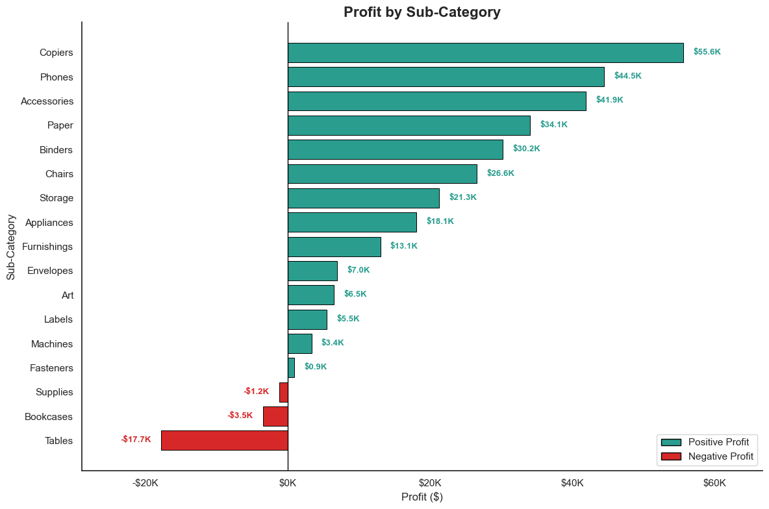
Correlation: Discount, Sales, Profit, Quantity
A correlation heatmap analysis exposes a critical flaw in the company’s current promotional strategy. While Sales and Profit share a predictable, positive relationship (0.479), discounting practices are actively destroying value. The data explicitly shows that Discounts have a negative correlation with Profit (-0.219), yet almost zero correlation with Sales (-0.028). (Additionally, order Quantity has a negligible impact on Profit at just 0.066).
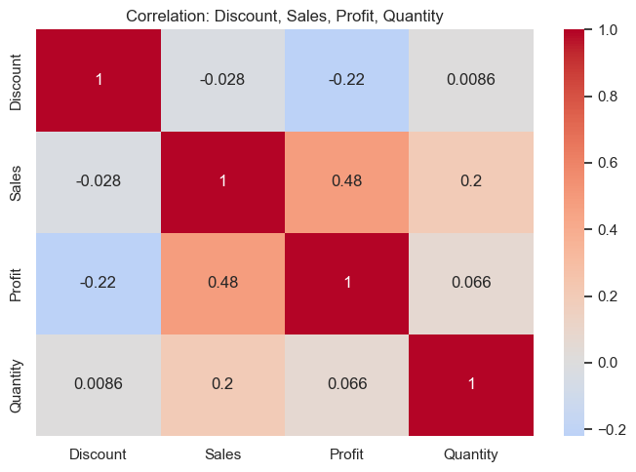
Revenue Breakdown by Segment:
Consumer is the largest segment, contributing 50.6% of total sales and 46.8% of total profit. Corporate ranks second, with 30.7% of sales and 32.1% of profit, showing slightly better profit efficiency than its sales share. Home Office has the smallest sales share at 18.7%, but contributes 21.1% of total profit. Overall, Consumer drives the largest revenue volume, while Corporate and Home Office appear more efficient in converting sales into profit.
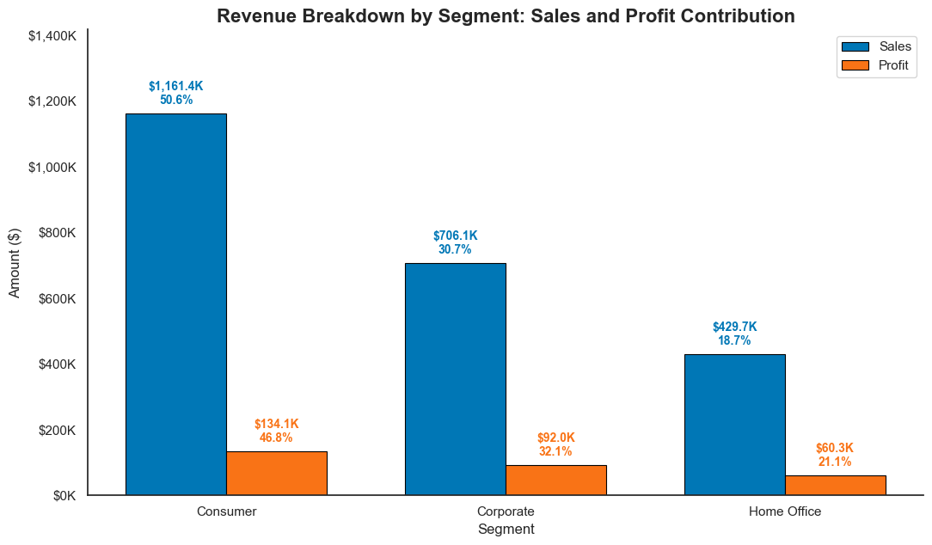
Customer Concentration Curve:
Treemap CategoryAnalysis of the Customer Sales Concentration Curve reveals a moderate, healthy revenue distribution: roughly 50% of the customer base (around 396 clients) drives 80% of total sales. While this protects the business from extreme single-client dependency, a severe profitability issue exists at the top.
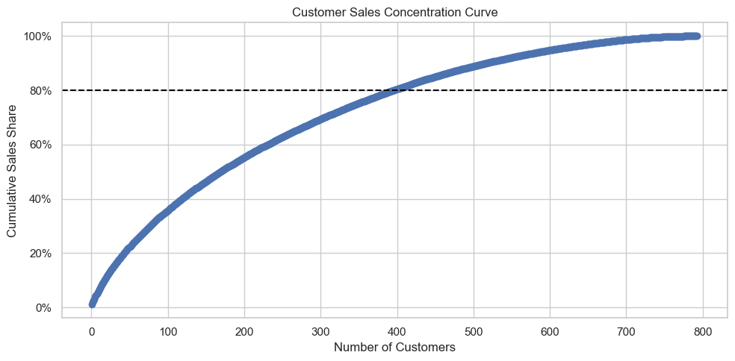
The data explicitly shows that high sales volume does not equate to high business value. A glaring example is the company's top-grossing client, Sean Miller, who brought in $25.0K in revenue but actually cost the company a $2.0K net loss.
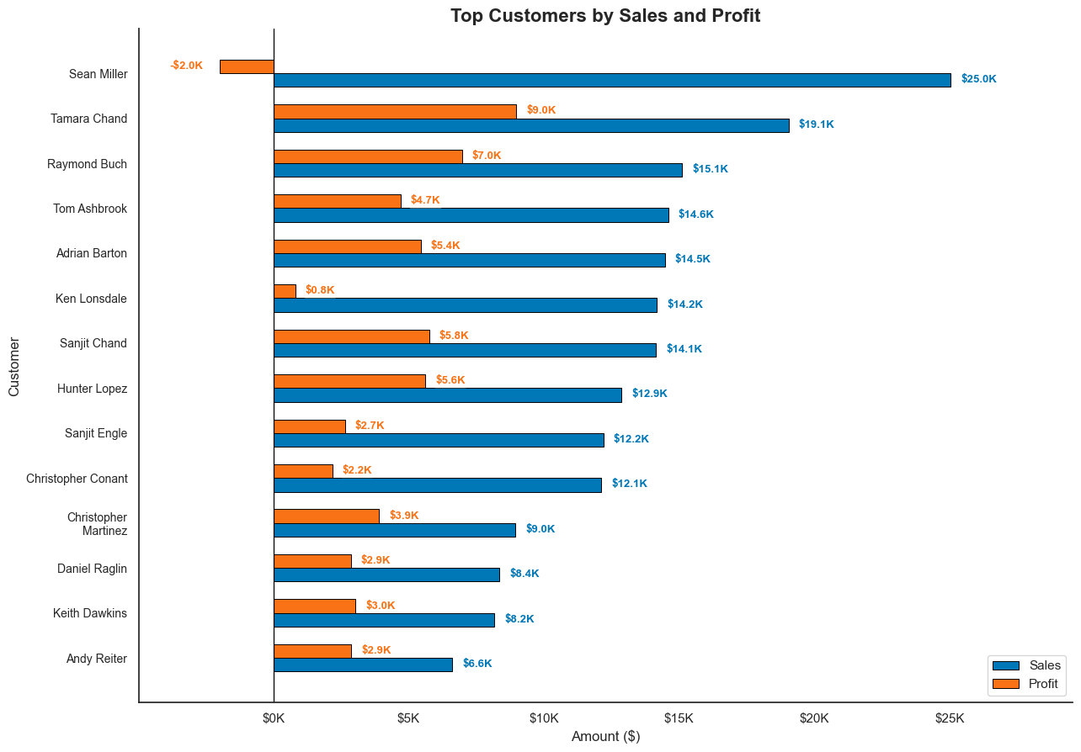
- Product and Sales Performance (Hường + Duyên)
Where revenue comes from (geography) + which products win/lose + discount diagnostics. This is the heaviest part, so split it into 3 sub-blocks:

By geography:
- Choropleth map by State (color = Profit).
- Bar chart of the 4 Regions — highlight: Central margin only 8% vs West 15%, East 14%.

By product
- → Sub-Category.
- Margin highlight: Furniture 2% while Technology & Office Supplies are both 17%.
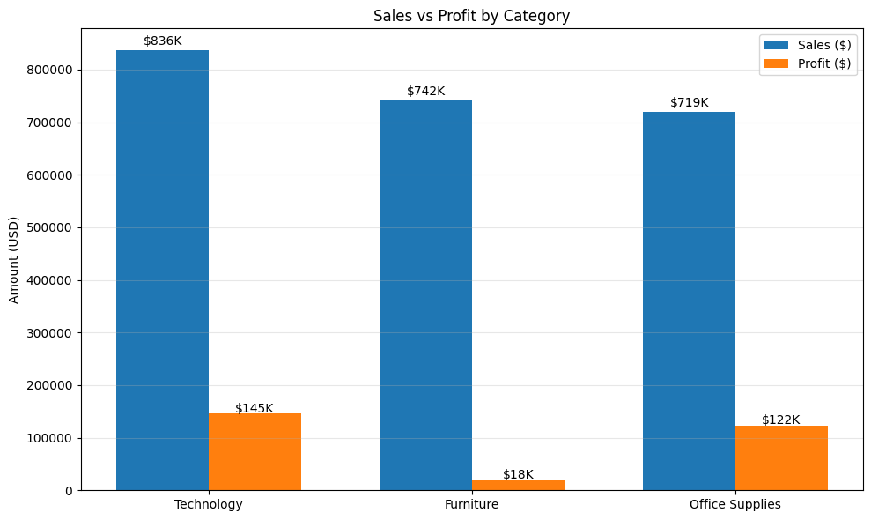
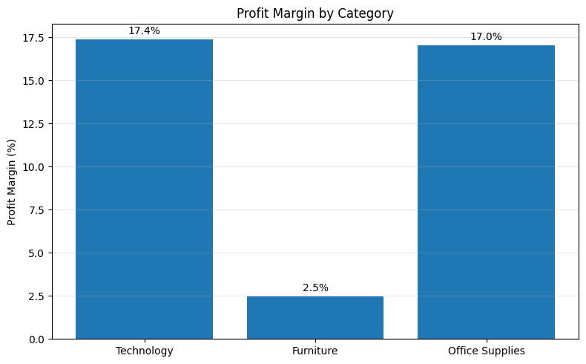
- Insight: The Furniture Profitability Trap

Key Finding
- Furniture contributes approximately one-third of total revenue but generates only a small portion of total profit.
- While Furniture accounts for nearly the same revenue share as Technology, its profit contribution is significantly lower and its profit margin is only around 2–3%.
- Decision
- Profitability improvement and margin management
- The company should restructure the furniture portfolio and redirect investment toward higher-margin product categories to maximize overall profitability.
- Table of net-loss Sub-Categories: Tables −$17.7K, Bookcases −$3.5K, Supplies −$1.2K → candidates to reprice or discontinue.
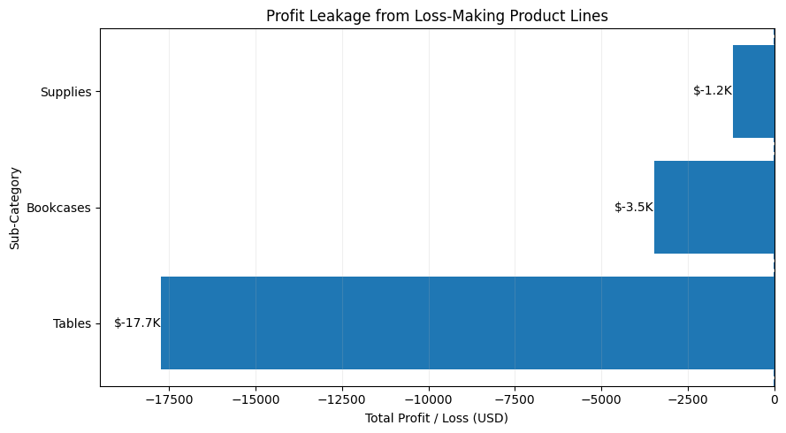
- Insight
- The company is generating revenue from Tables, Bookcases, and Supplies, but these sub-categories consistently produce negative profits, reducing the overall profitability of the product portfolio.
- Key Findings
- Tables recorded the largest loss (−$17.7K).
- Bookcases generated a loss of (−$3.5K).
- Supplies generated a loss of (−$1.2K).
- These sub-categories contribute sales but destroy profit.
- Profit generated by high-performing products is partially offset by losses from these categories.
- Decision
- Management should prioritize pricing, cost, and portfolio optimization to prevent further erosion of overall profitability
- Review pricing and discount strategies for loss-making sub-categories.
- Investigate root causes of negative profitability.
- Reduce inventory exposure for persistently unprofitable products.
- Consider discontinuing low-performing SKUs if profitability cannot be improved.
Discount diagnostics
- Scatter Discount vs Profit + bar of average profit by discount band:
- 0% → +$67/line · 1–20% → +$27 · >20% → negative (20–40%: −$78).
- Warning KPI: 18.7% of line items are sold at a loss → recommend capping discounts at ~20%.
- 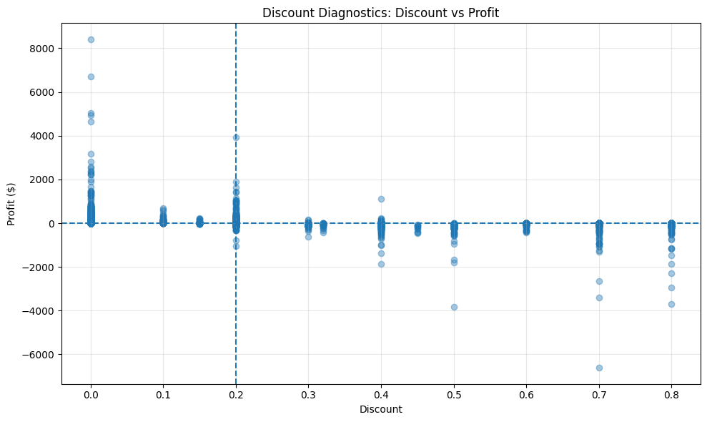
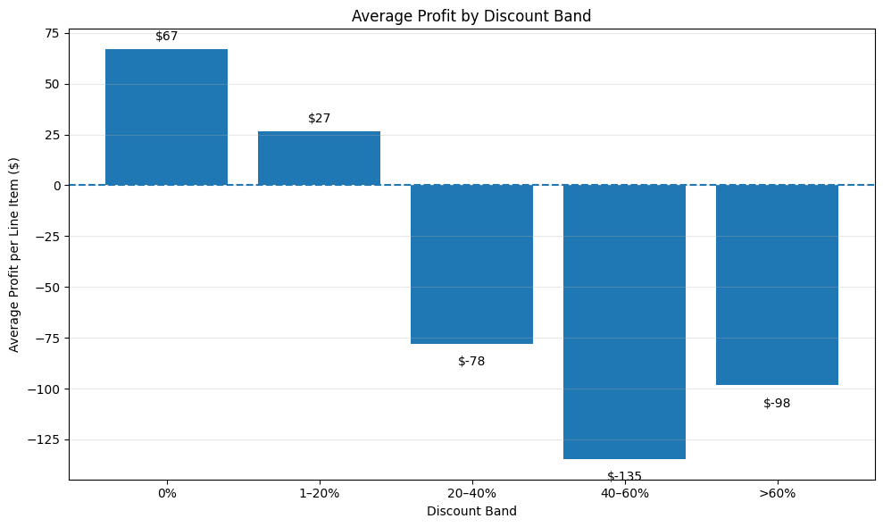

Insight
- Profit turns increasingly negative when discounts exceed 20%, indicating that aggressive discounting is eroding overall profitability.

Key Findings
- Most highly profitable transactions occur at 0% discount.
- Profitability deteriorates significantly beyond 20% discount.
- Large losses are concentrated in heavily discounted transactions (50–80%).

Decision
- Implement discount governance and cap standard discounts at approximately 20% to protect profit margins.

Delivery Status
- Customer (Thảo)
Who buys, who's most valuable, who to retain (Customer information, region)
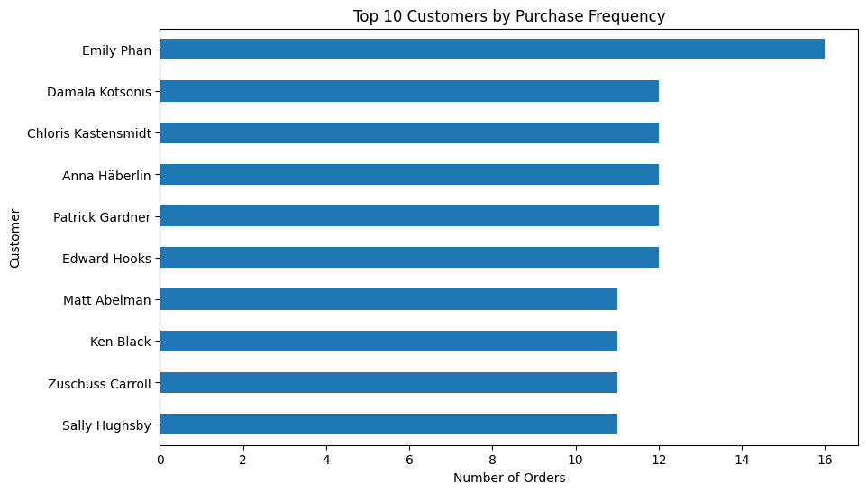
Emily Phan is the most active customer with 16 orders, significantly higher than other customers.
Most top customers placed 11–12 orders, indicating a relatively stable and loyal customer base.
The gap between Emily Phan and the rest suggests that she is an exceptionally engaged customer.
=> Emily Phan is the most frequent buyer and represents a highly loyal customer segment.
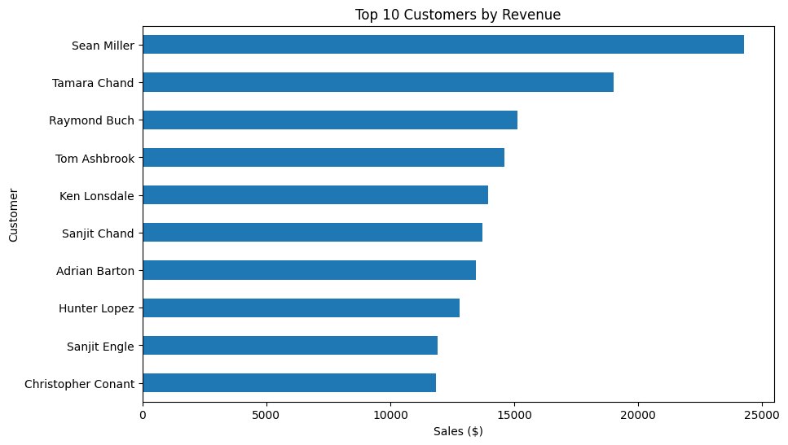
Sean Miller generated the highest revenue, approximately $24,000+.
Tamara Chand ranked second, followed by Raymond Buch.
The revenue contribution among top customers is highly concentrated, with the top few customers contributing significantly more than the others.
=> Sean Miller is the largest revenue-generating customer for the company.

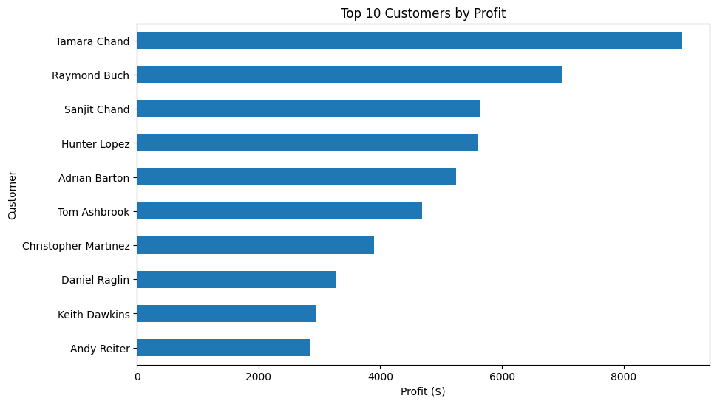
Tamara Chand generated the highest profit (around $9,000).
Raymond Buch and Sanjit Chand are also highly profitable customers.
Sean Miller does not appear among the top profit contributors despite generating the highest revenue.
=> Tamara Chand is the most valuable customer because she generates the highest profit, not just high sales.

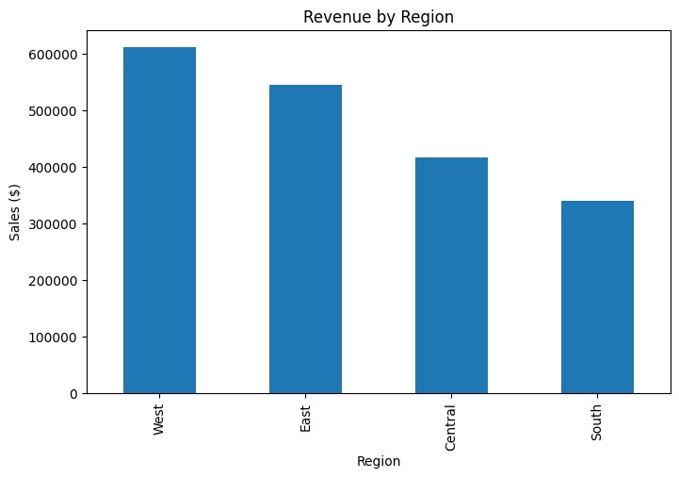
The West region generated the highest sales revenue (over $600,000).
The East region ranked second.
The South region contributed the lowest revenue.
=> The West region is the company's strongest market in terms of revenue generation.

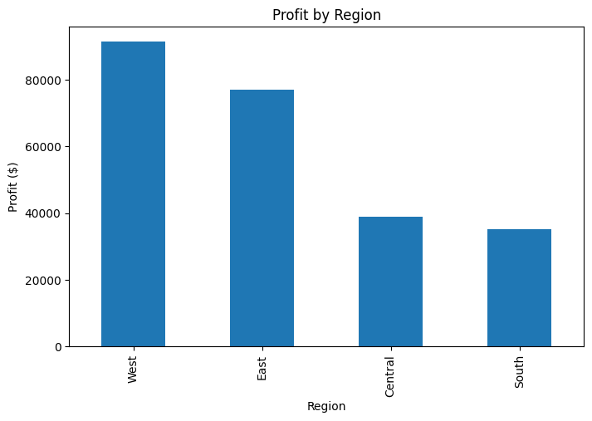
The West region generated the highest profit, followed by the East region.
The Central and South regions contributed substantially lower profits.
The ranking of profit closely follows the ranking of revenue.
=> The West region is not only the largest revenue contributor but also the most profitable market.
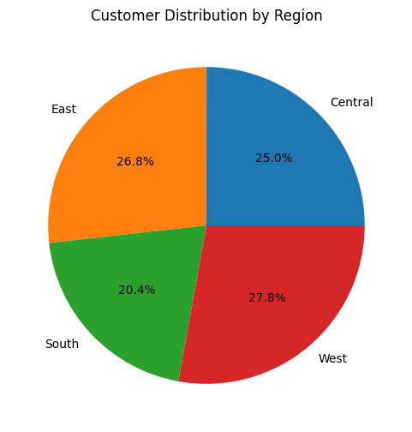
The customer base is relatively evenly distributed across regions.
The West region has the highest share of customers (27.8%).
The South region has the lowest share (20.4%).
=> Customer distribution is balanced, but the West region has the largest customer base and therefore greater market potential.

RFM analysis
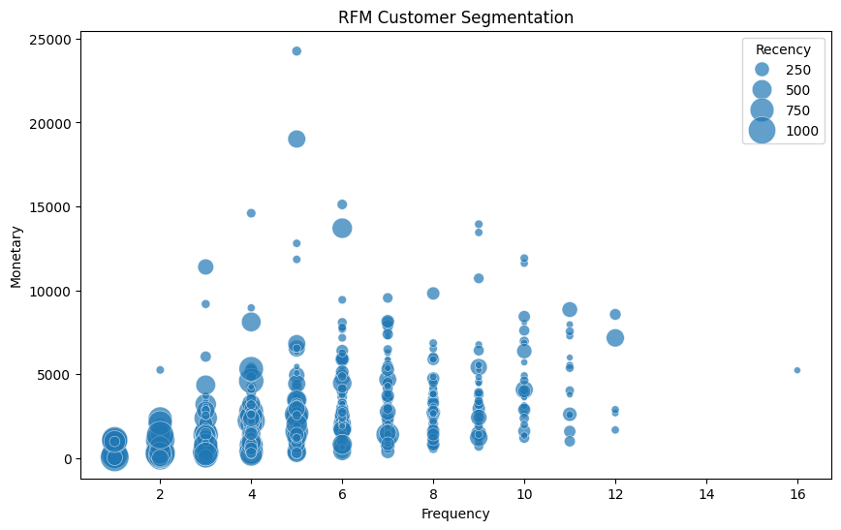

Most customers have a purchase frequency between 2 and 8 orders and relatively low-to-moderate monetary value.
A small group of customers generates exceptionally high spending (Monetary > $10,000), representing the company's most valuable customers.
Large bubbles indicate customers with high recency values (long time since last purchase), suggesting potential churn risk.
Several high-spending customers also have large bubble sizes, indicating they may be valuable but inactive customers.
=> the company should prioritize retaining high-spending customers with high recency scores, as they represent valuable customers who may be at risk of churning.

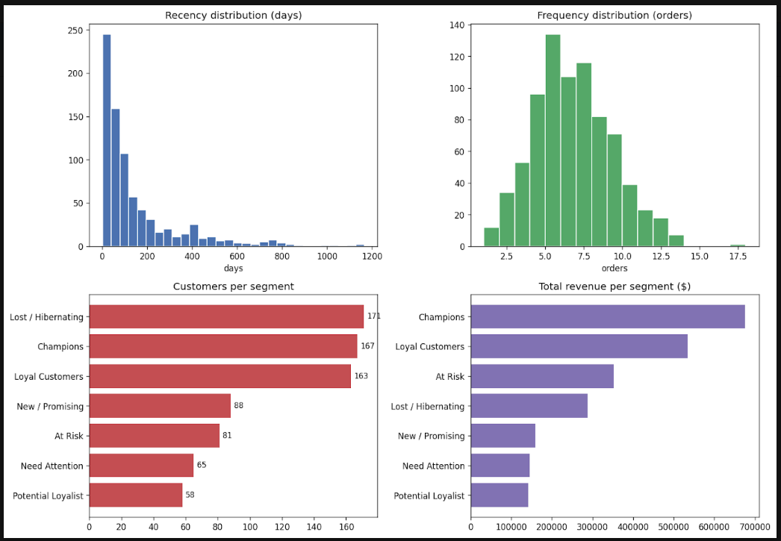

5. Advanced Analysis: (Chi)
Apply Clustering method on RFM to find how manyApply Clustering method on RFM to find how many. Compared with segments are classified by marketing rules.

